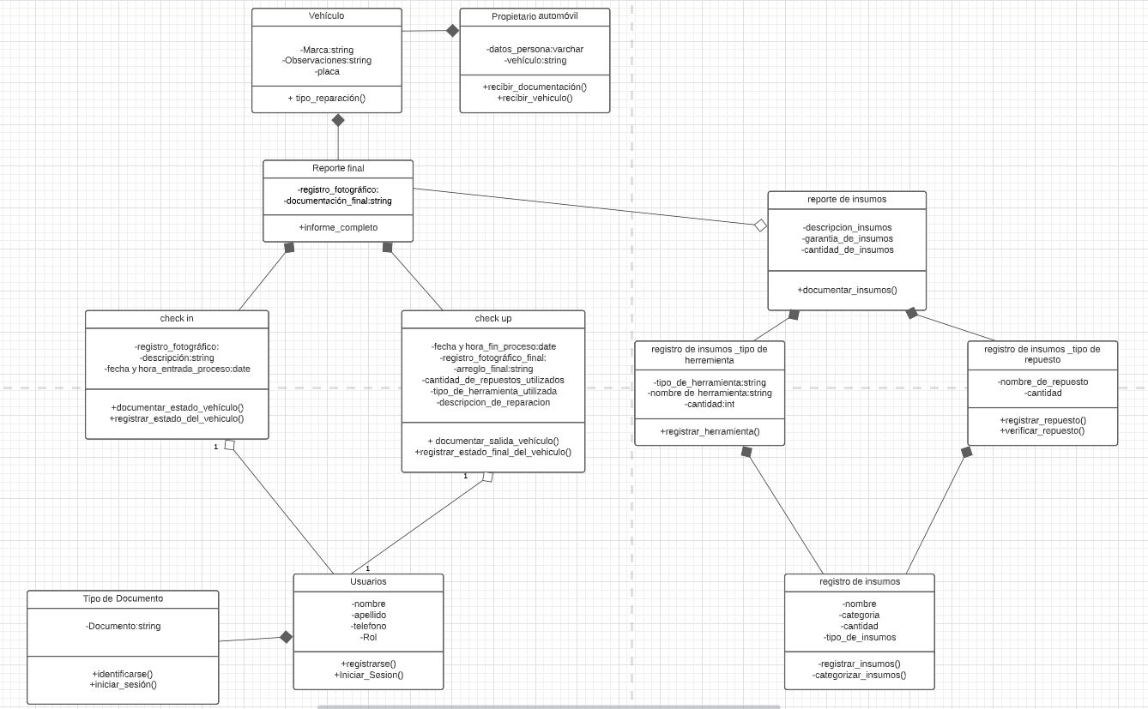

**Link Herramienta:** [*https://lucid.app/lucidchart/95206aaf-e5b7-4d0c-aaf7-563a30781c6f/edit?viewport_loc=-1825%2C-900%2C3430%2C1713%2C0_0&invitationId=inv_e4c6e768-6157-4219-a62e-f71d68f28bae#*](https://lucid.app/lucidchart/95206aaf-e5b7-4d0c-aaf7-563a30781c6f/edit?viewport_loc=-1825%2C-900%2C3430%2C1713%2C0_0&invitationId=inv_e4c6e768-6157-4219-a62e-f71d68f28bae#)